“SMOKIN’ ON THE POINT”
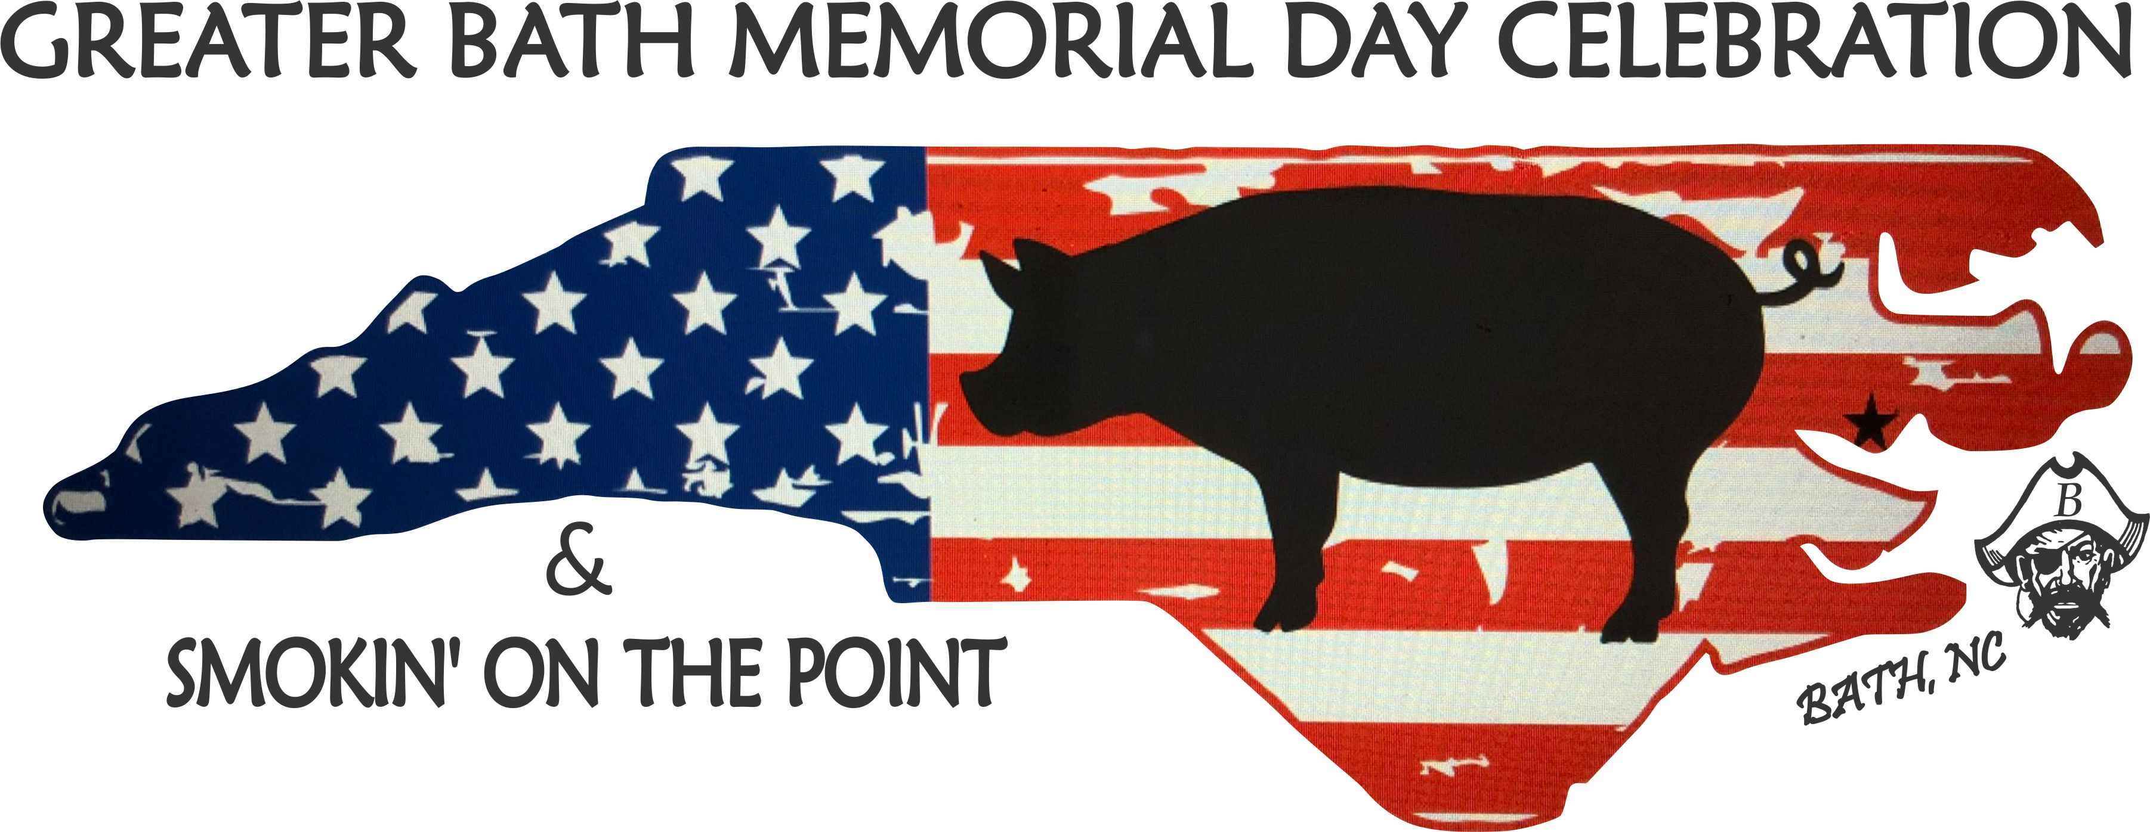
2020 Official Rules and Regulations

On Site Judging/ Product Quality Prizes
1st - $1000 & trophy
2nd - $750 & trophy
3rd - $500 & trophy
High Score Natural Source - $500 and trophy

- All cooking spaces will be numbered and pre-assigned by the Contest Director. No changes will be allowed. Space is limited, maximum teams is 40.
- A Contest official will direct you to your site. Each team is required to be checked in no later than 6:00 p.m. on Friday, May 22, 2020.
- Teams will be permitted to begin setting up their equipment any time after 12:00 noon, May 22, 2020.
- Each cooking space will be limited to a 20’ x 24’ area. For each 20’ x 24’ area one pig must be cooked. There will be room for your tent. All vehicles must be parked off-site as to make room for additional tents/cookers.
- Chief Cooks meeting will begin at 7:00 p.m., Friday evening May 22nd, location will be announced upon registration. Attendance is mandatory.
- Each cooking team shall have one person designated as Chief Cook. The Chief Cook shall be the only person permitted to present the pig during the judging process.
- The Contest will provide a 110-130 lb. Pig. Pigs will be distributed on Friday, May 22, 2020 between 8:00 and 9:00 pm and the contest will officially begin at that time.
- All pigs must be cooked in an above ground cooker. Should a gas cooker be used, it must meet the safety standards such as proper regulator, tanks must be secured to prevent accidentally being overturned and any other requirements the Festival Director deems for safety precautions.
- The USE OF GASOLINE FOR ANY REASON IS STRICTLY PROHIBITED.
- Cooking teams are requested to keep their cooking area free of trash. Please use the trash containers provided at various locations. Each team is responsible for site cleanup at the end of the contest.
- All cooking teams are requested to be discrete with any alcoholic beverages consumed on the contest premises. Law Enforcement Officers will be present.
- All cooking teams are requested to respect the rights of others in attendance for the
Contest and event, with special emphasis from each team member relating to loud music, loud or profane language or infringement on adjoining sites with any equipment, cookers, cars, campers, vans, pickups, etc. Curfew for quiet time will be midnight. Security will be provided throughout the evening.
- Food and beverages will be available on Friday evening.
- Gloves are not mandatory, but a basin of water and soap is mandatory for cleanliness purposes.
- Cooks are no longer allowed a pass.
- A Contest official will be assigned to accompany the judges while the pigs are being judged. The staff person will collect score sheets. The score sheets will contain no information that will in any manner identify the cooks or sponsors. The Festival staff or secured CPA, not the judges, will total and grand total the score sheets.
- Pigs should not be sauced inside or out. Those pigs that have been sauced will be disqualified.
- No external heat source may be used other than the grill. Some examples might include but are not limited to, heat guns and torches. Those using external heat sources will be disqualified.
- Injecting pigs will not be allowed. Some examples might include but are not limited to, sauce and product drippings. Those injecting pigs will be disqualified.
- Following the judging for On Site Judging, the pigs shall be kept warm until picked up
by the Festival staff. All pigs, except for the ribs, must be turned in chopped, following judging.
- In the event of a tie, Contest Staff will refer back to the judging sheets and the winner will be awarded by the highest points in category, meat taste. If still a tie, then skin crispiness, then moisture.
- Contest officials maintain the decision to distribute or mail the score sheets, following the
announcement of winners. Score Sheets will be given or mailed to the Chief Cooks.
- Contest winners will be announced at approximately noon on Saturday, May 23, 2020. (or as soon as judging is completed and results are calculated).
- All checks for product quality and showmanship will be given to the Chief Cook the day of the Contest. Trophies will be presented to the Chief Cook on Saturday, May 23, 2020.
- Each team will receive four complimentary BBQ sandwiches.
- All cookers and equipment must be removed no later than 5:00 p.m., May 23, 2020, unless special permission is granted. The Greater Bath Foundation or State Historic Site shall not be responsible for any cookers or equipment left on the premises after 5:00 p.m., May 23, 2019.
- Please specify to event coordinator if you would like to participate in the Showmanship and/or People’s Choice.

Afternoon celebration will feature a free concert by “THE EMBERS” brought to you by the

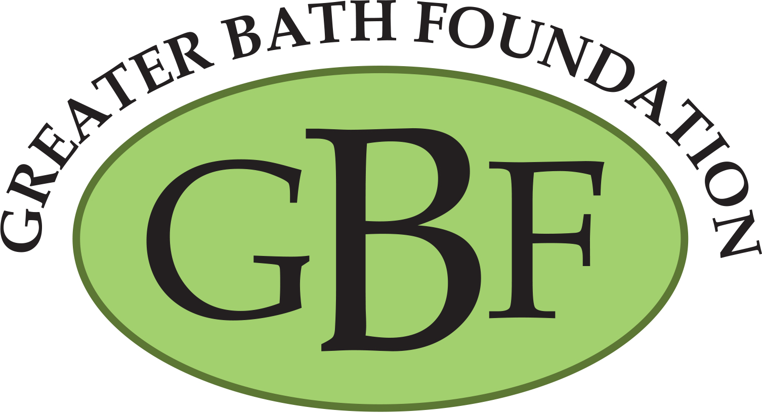

Please contact Evan Woolard @ 252-402-0119 before sending any entry form money.

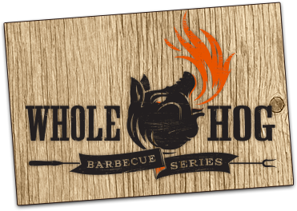
“SMOKIN’ ON THE POINT”
2020 Official Entry Form

Entry Fee - $150
Make Check payable to, and mail to; Greater Bath Foundation
P. O. Box 7
Bath, NC 27808

Please contact Evan Woolard @ 252-402-0119 before sending any entry form money.

Official Team Name: _______________________________________________________________________________
Chief Cook: __________________________________________________________________________________________
Address: _____________________________________________________________________________________________
City: ___________________________________________ State: _____________ Zip: ___________________________
Email: ________________________________________________________________________________________________
Phone#: ________________________________________ Cell#: _____________________________________________
Number of people on Team: _______________________________________________________________________
I will be cooking with: Natural Source_________ Gas _________
I have read and agree to abide by all rules for Smokin’ on the Point to be held on May 22-23, 2019.

Signature: _________________________________________________________ Date: _________________________

Please select
I have my own sponsor: _______ Sponsor Name:_______________________________________________
I need a sponsor: _________

I would like to participate in: People’s Choice ___________
Showmanship_____________

